**Laptop Price Prediction**

**DATA:**

**Data before preprocessing:**

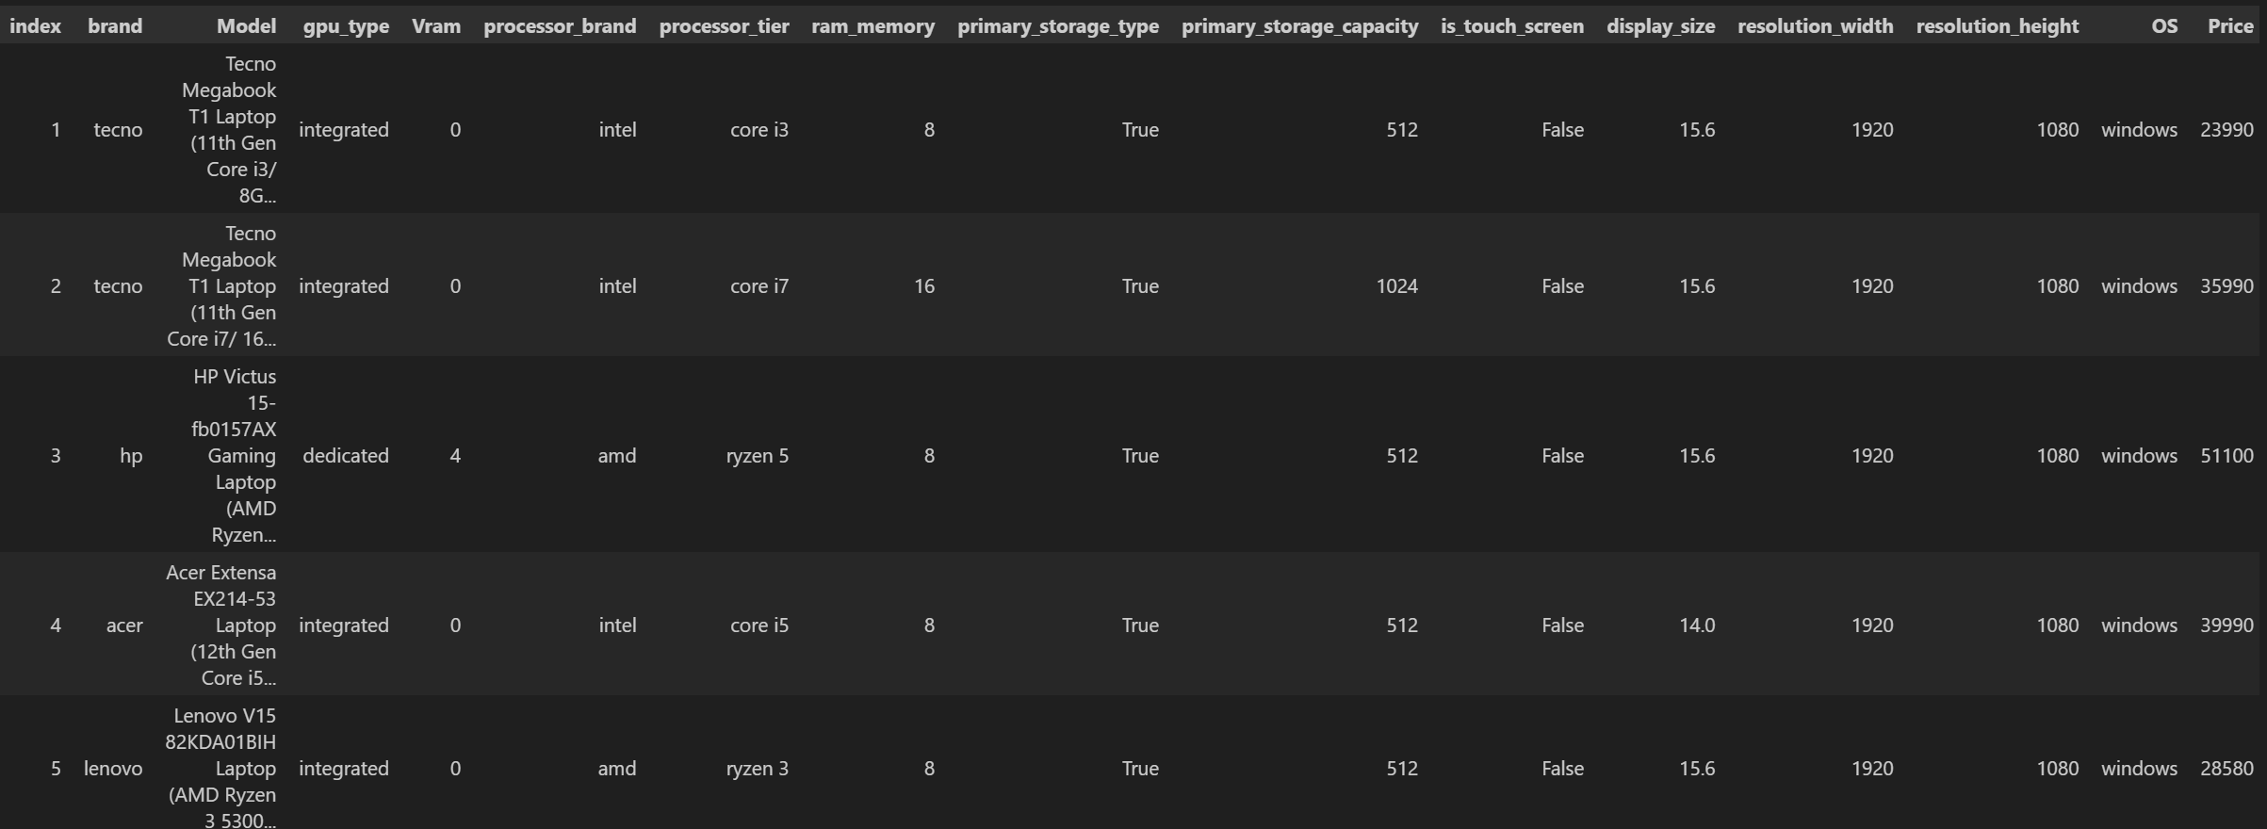

**Data shape before preprocessing:**

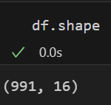

**Data info:**

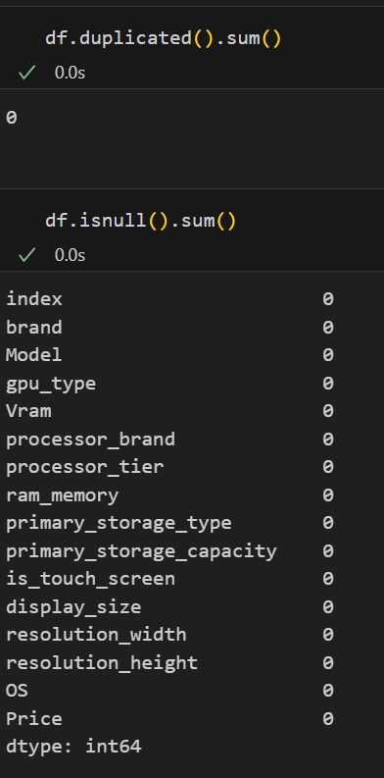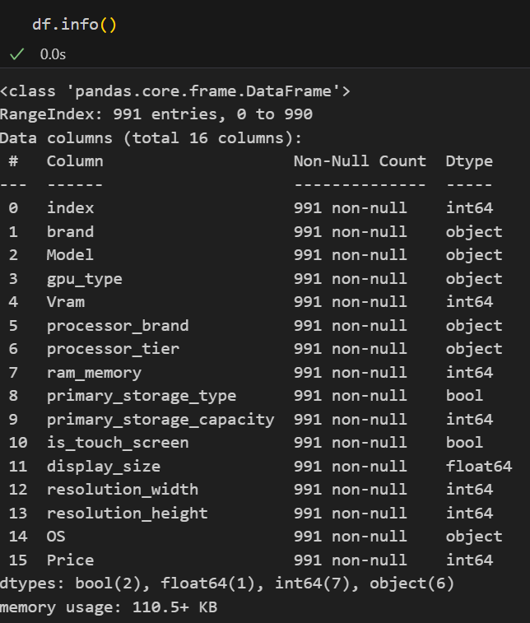

**Data after preprocessing:**

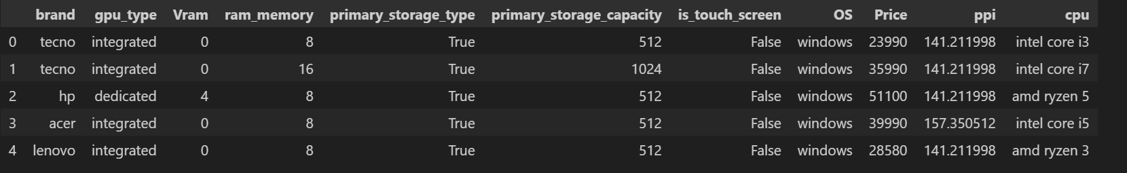

Data shape:

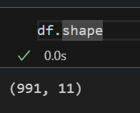

**Distribution of price:**

sns.distplot(df['Price'])

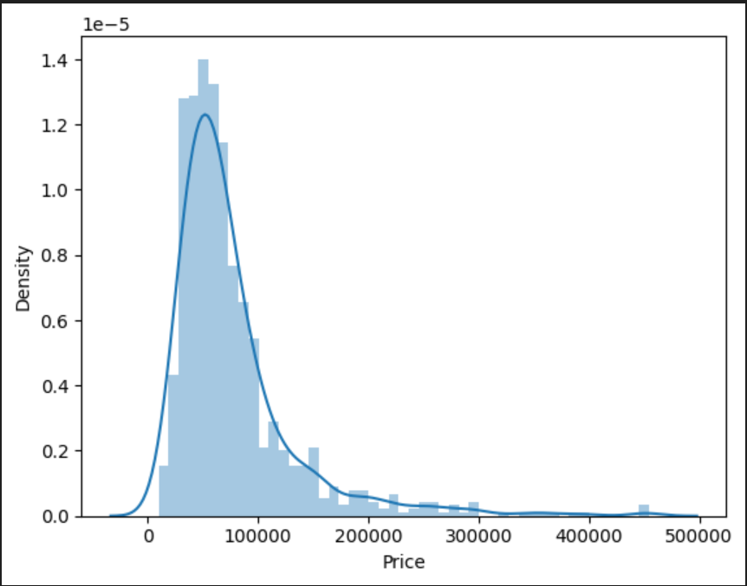

**Corelation matrix:**

df_numeric = df.select_dtypes(include=['number'])

df_numeric.corr()['Price']

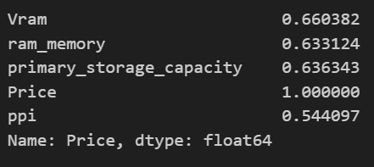

**Heatmap:**

sns.heatmap(df_numeric.corr())

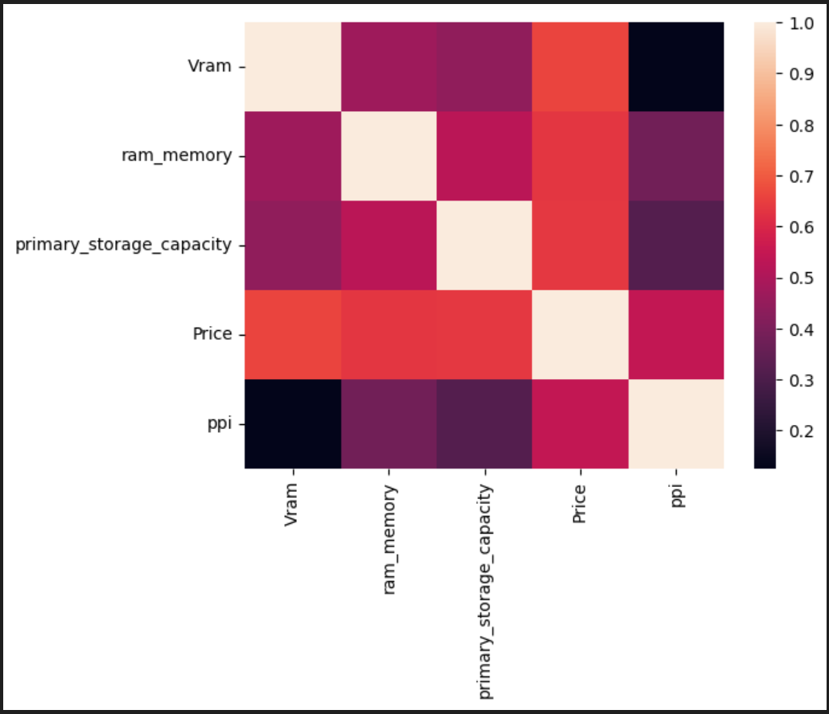

**MODELS:**

**Linear Regression:**

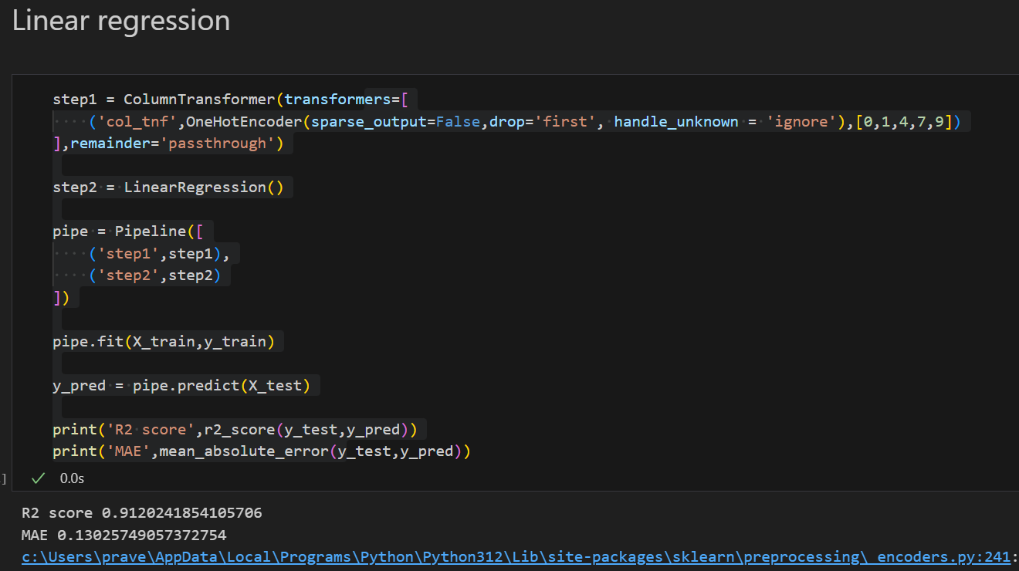

**Accuracy:** 91%

**Ridge Regression:**

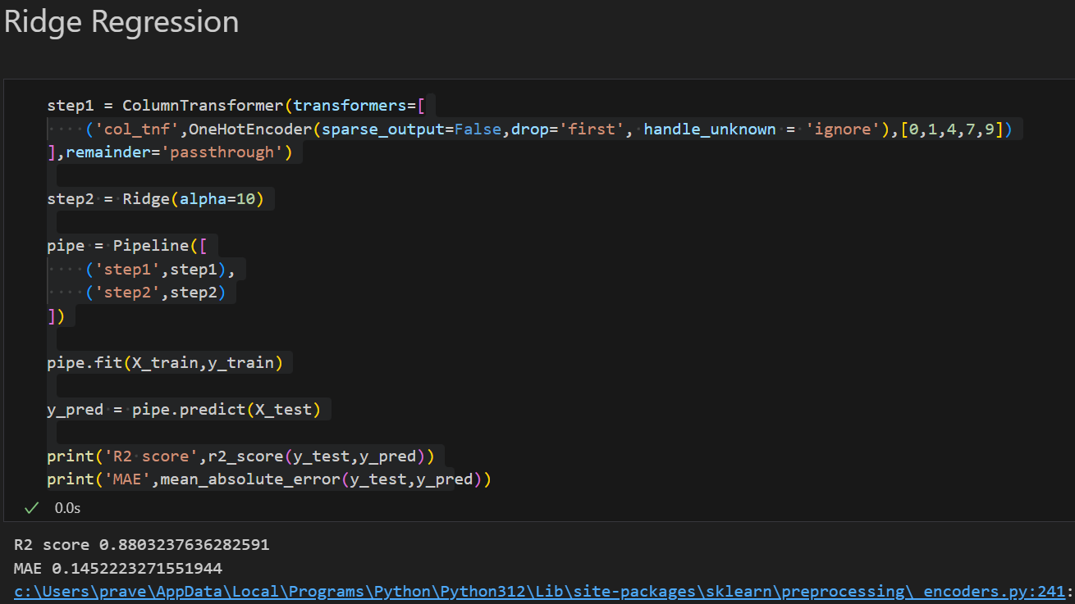

**Accuracy:** 88%

**Lasso Regression:**

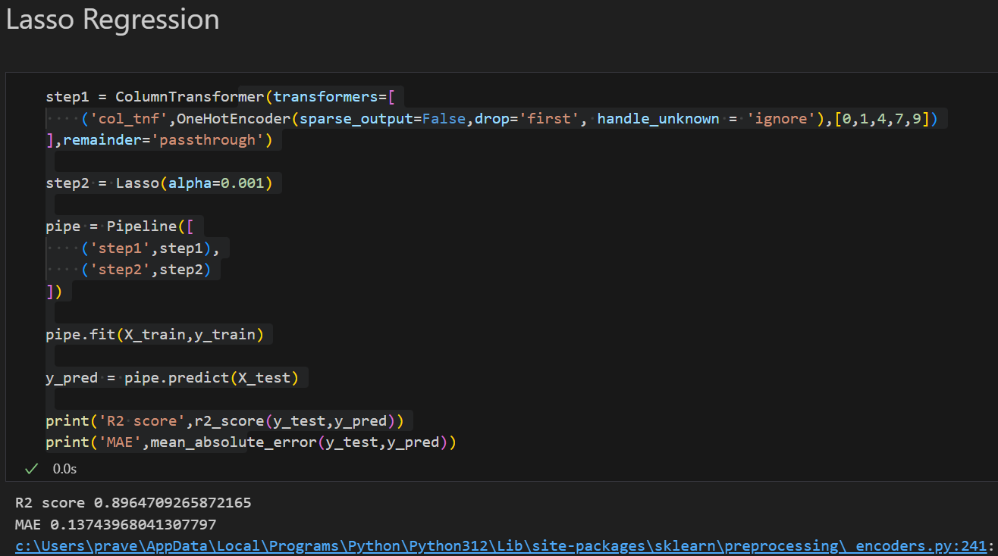

**Accuracy:** 89%

**Decision Tree:**

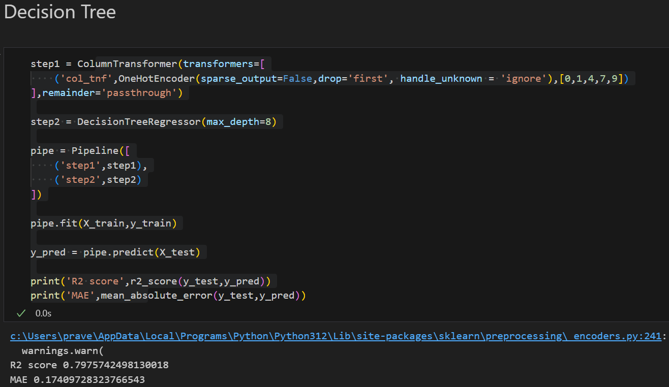

**Accuracy:** 79%

**Random Forest:**

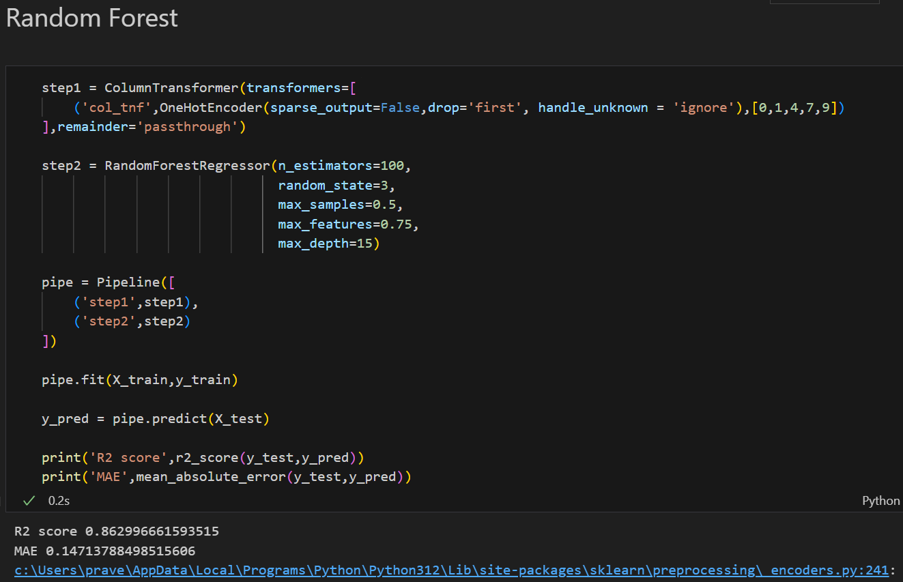

**Accuracy:** 86%

**KNN:**

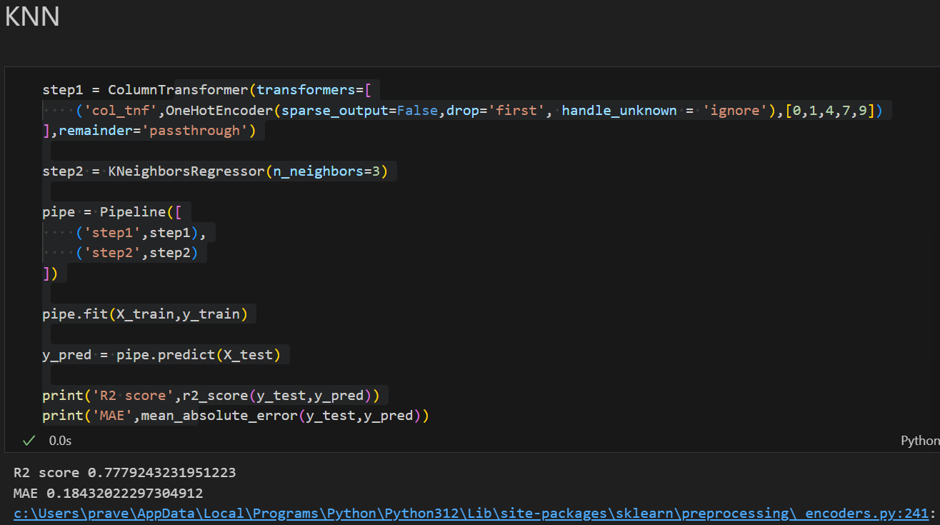

**Accuracy:** 77%

**SVM:**

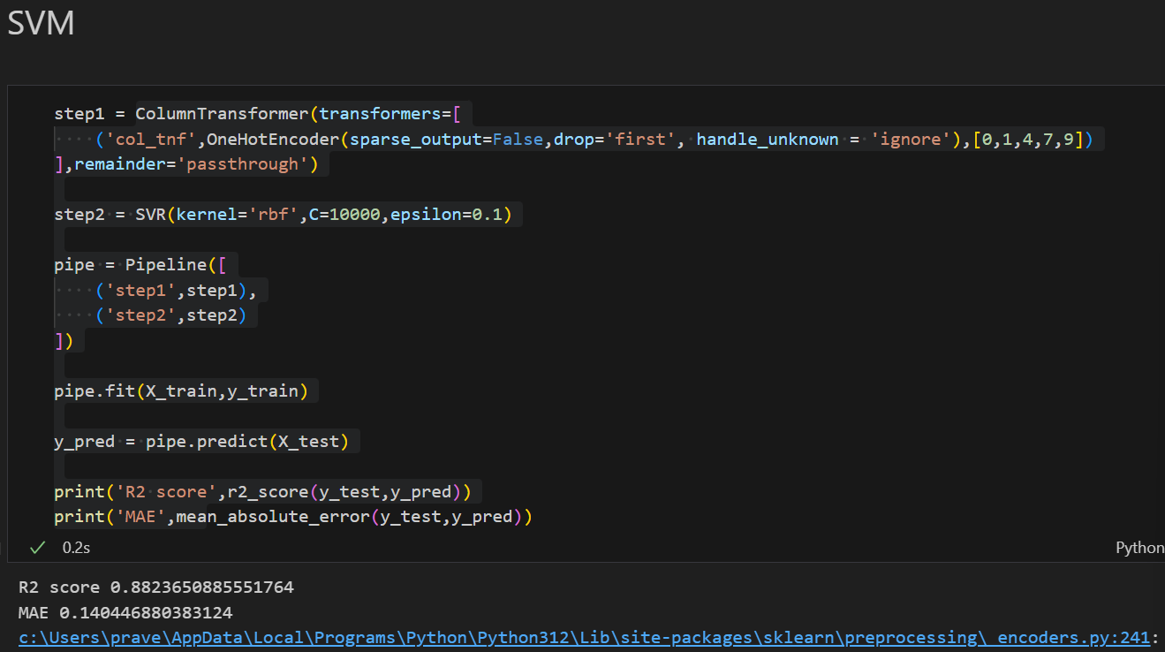

**Accuracy:** 88%

**Gradient Boost:**

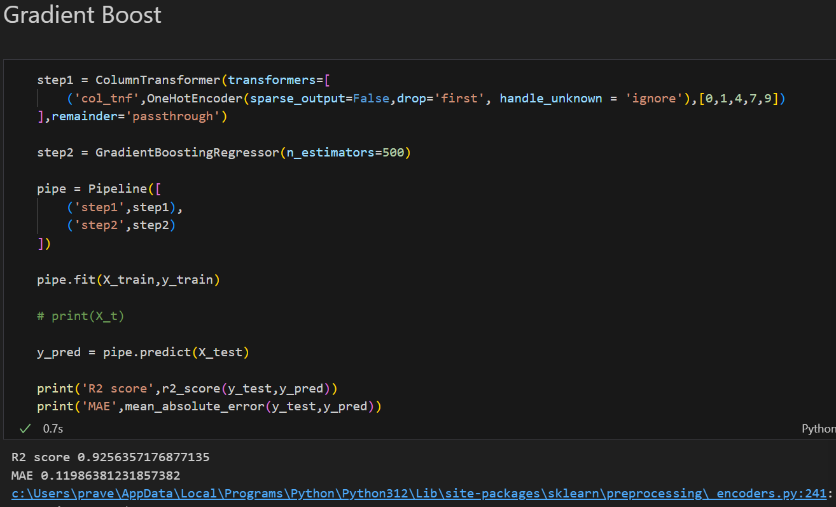

**Accuracy: 92%**

**XgBoost:**

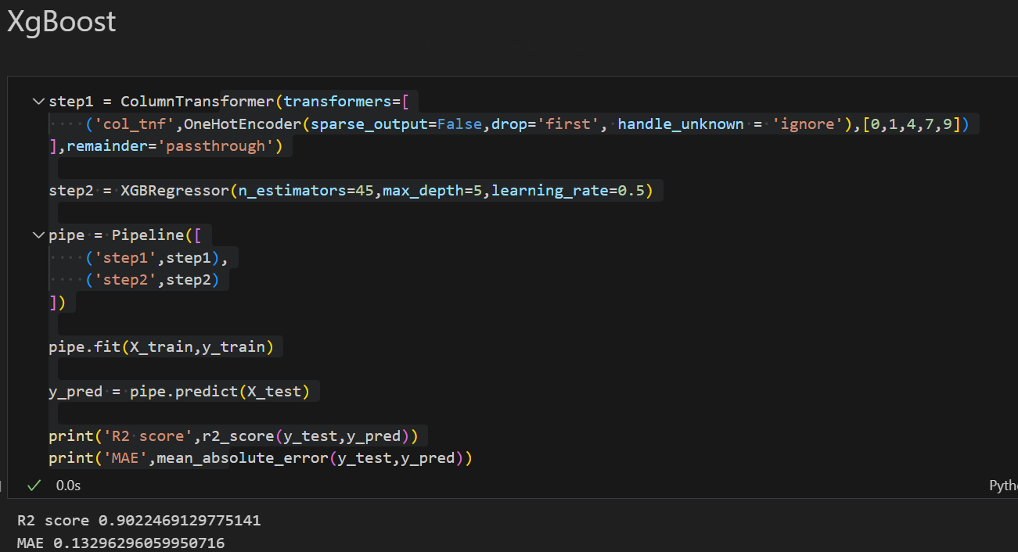

**Accuracy:** 90%

**Conclusion:**

Gradient Boost has the highest accuracy among the given Models, followed by linear regression and XgBoost.